**EXP 5**

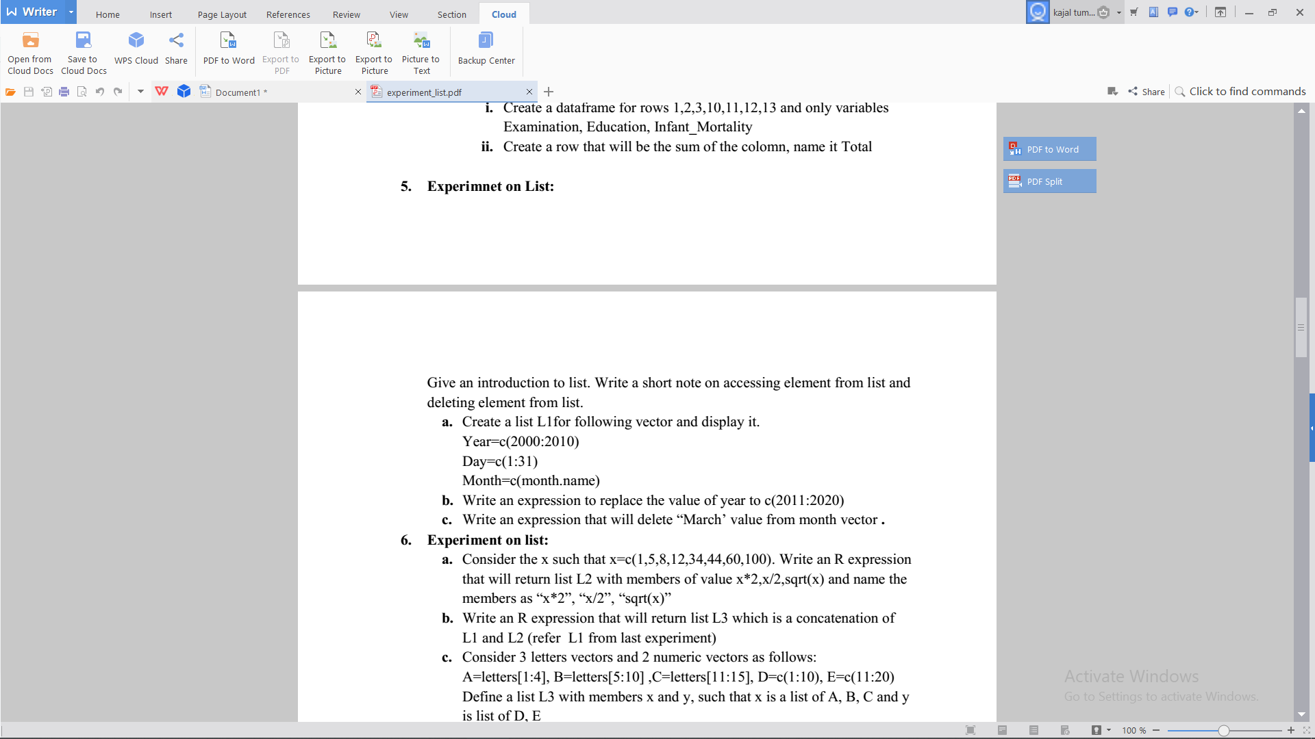

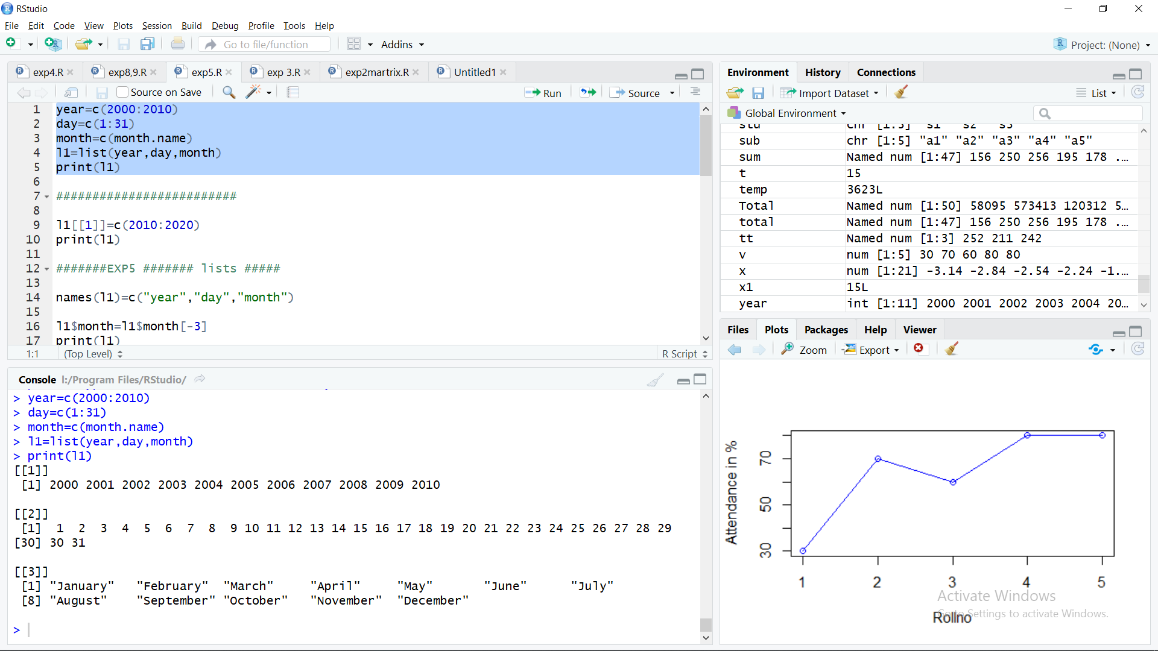

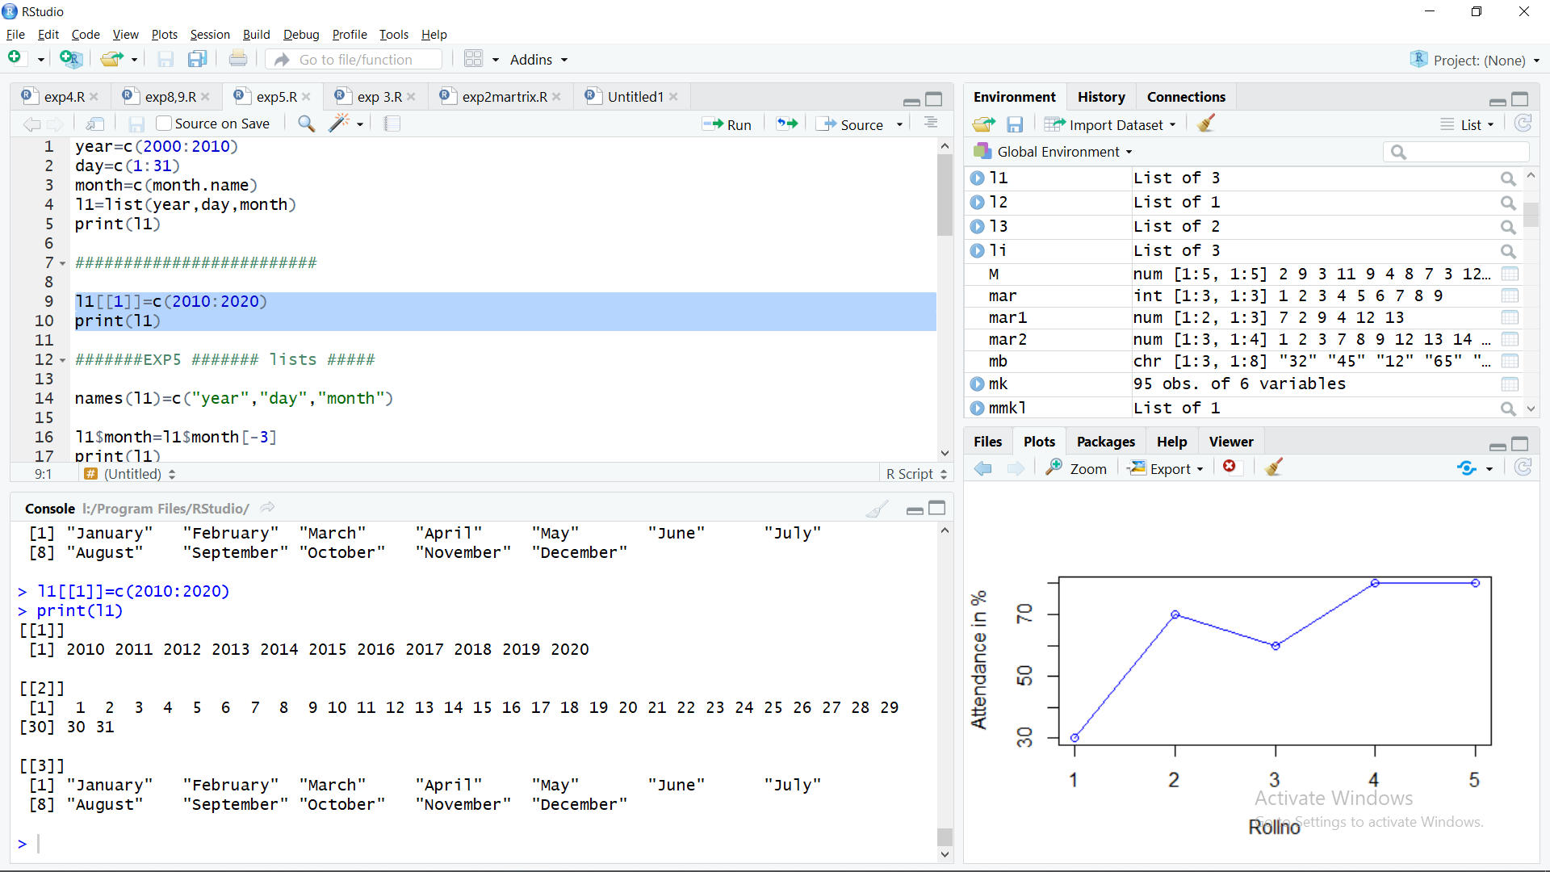

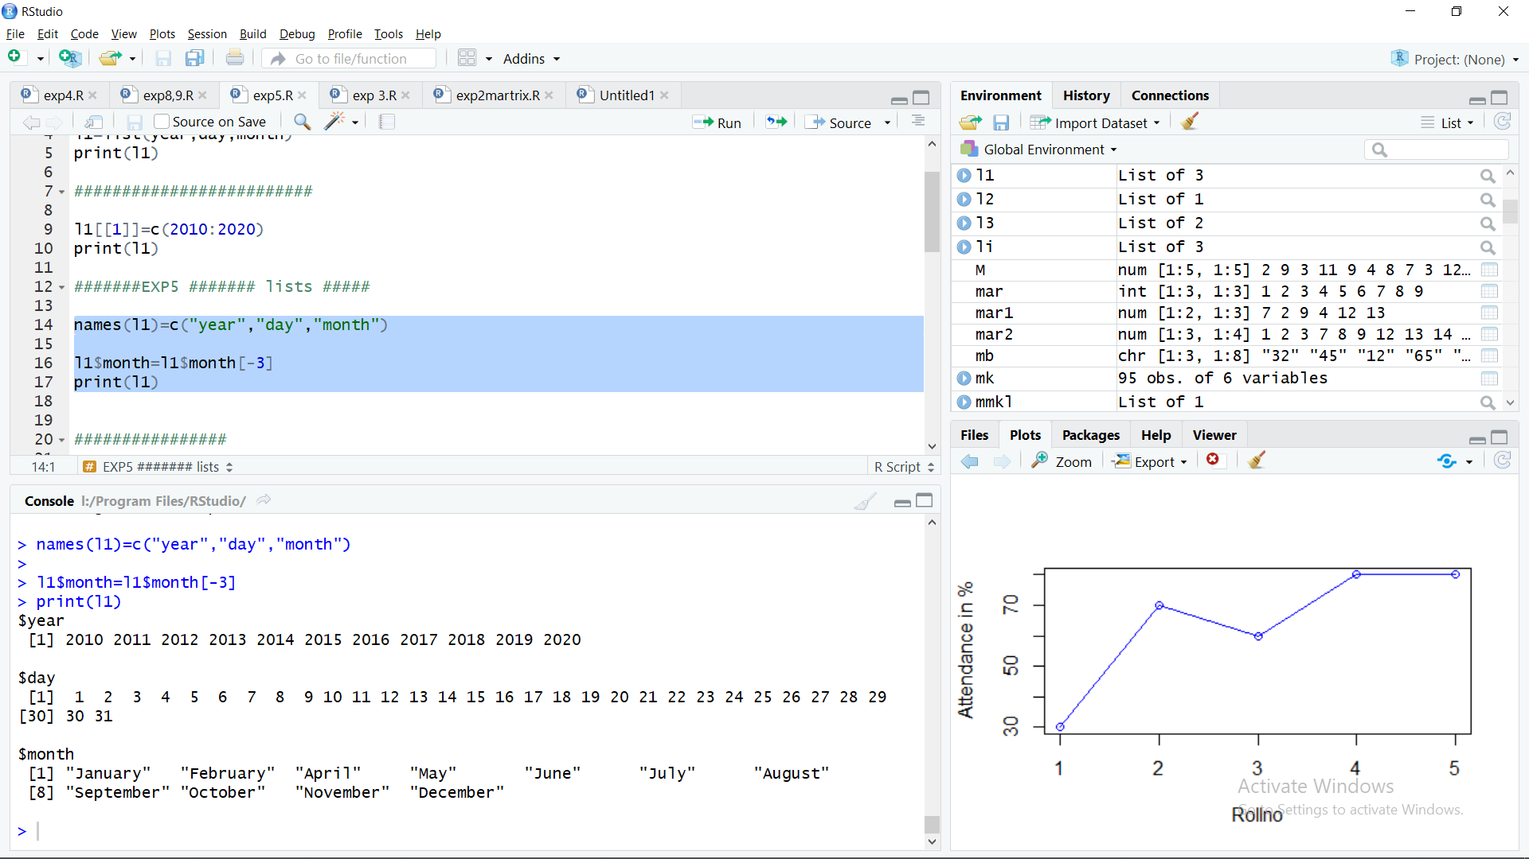

**EXP 9**

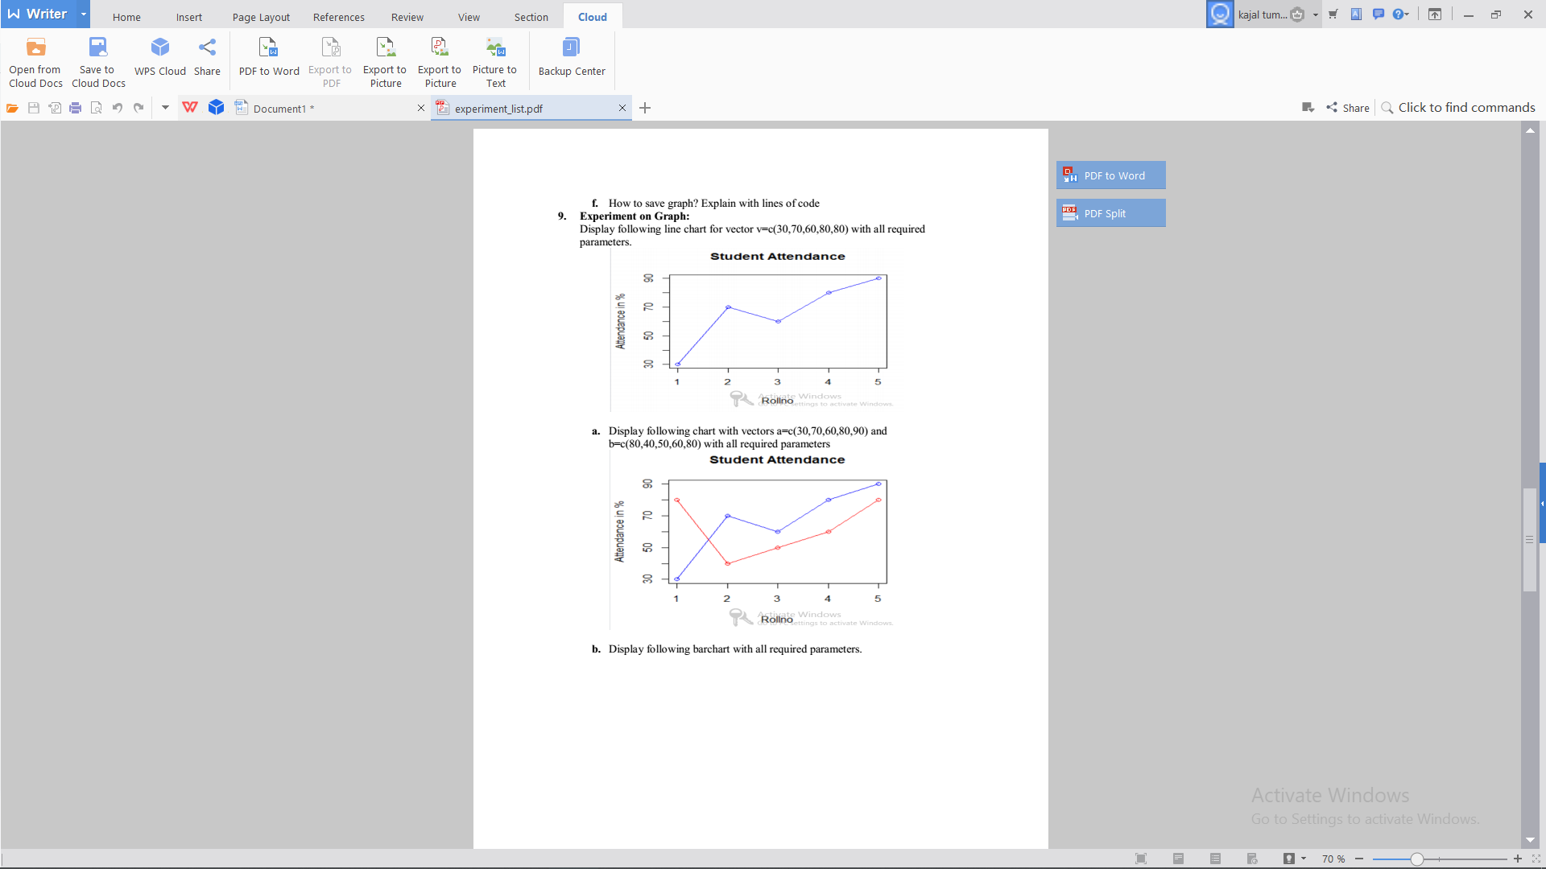

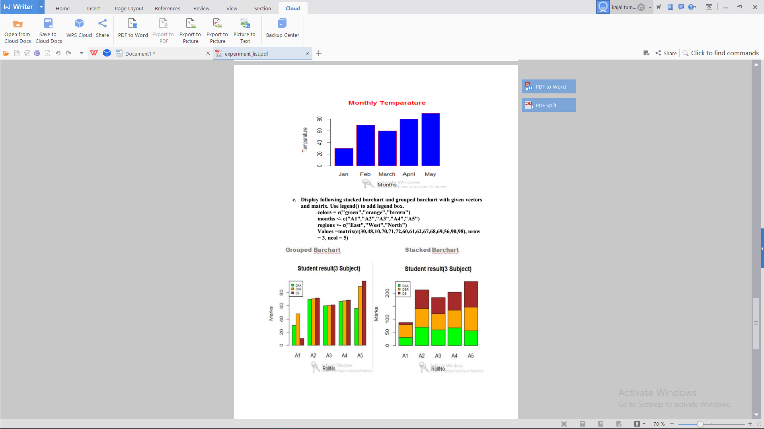

v=c(30,70,60,80,80)

plot(v,type="o",col="blue",xlab="Rollno",ylab="Attendance in %")

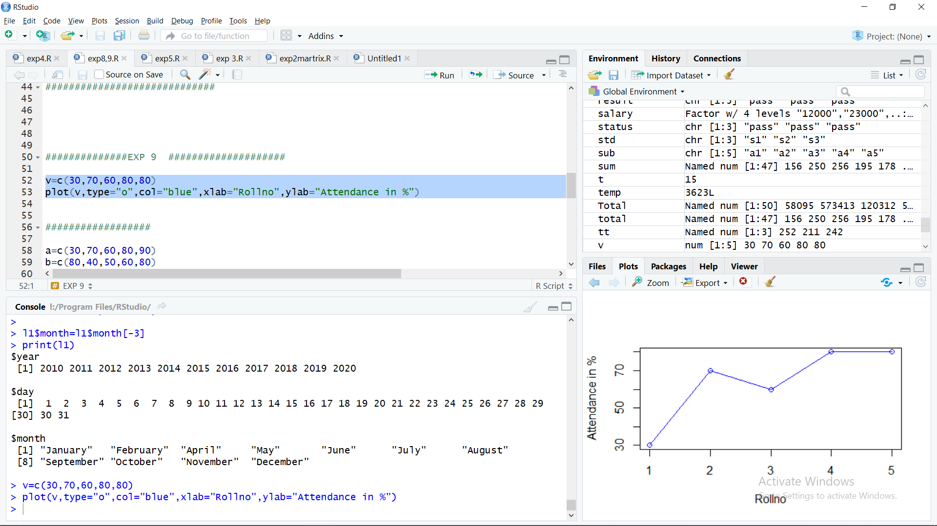

a=c(30,70,60,80,90)

b=c(80,40,50,60,80)

plot(a,type="o",col="blue",xlab="Rollno",ylab="Attendance in %")

lines(b,type="o",col="red")

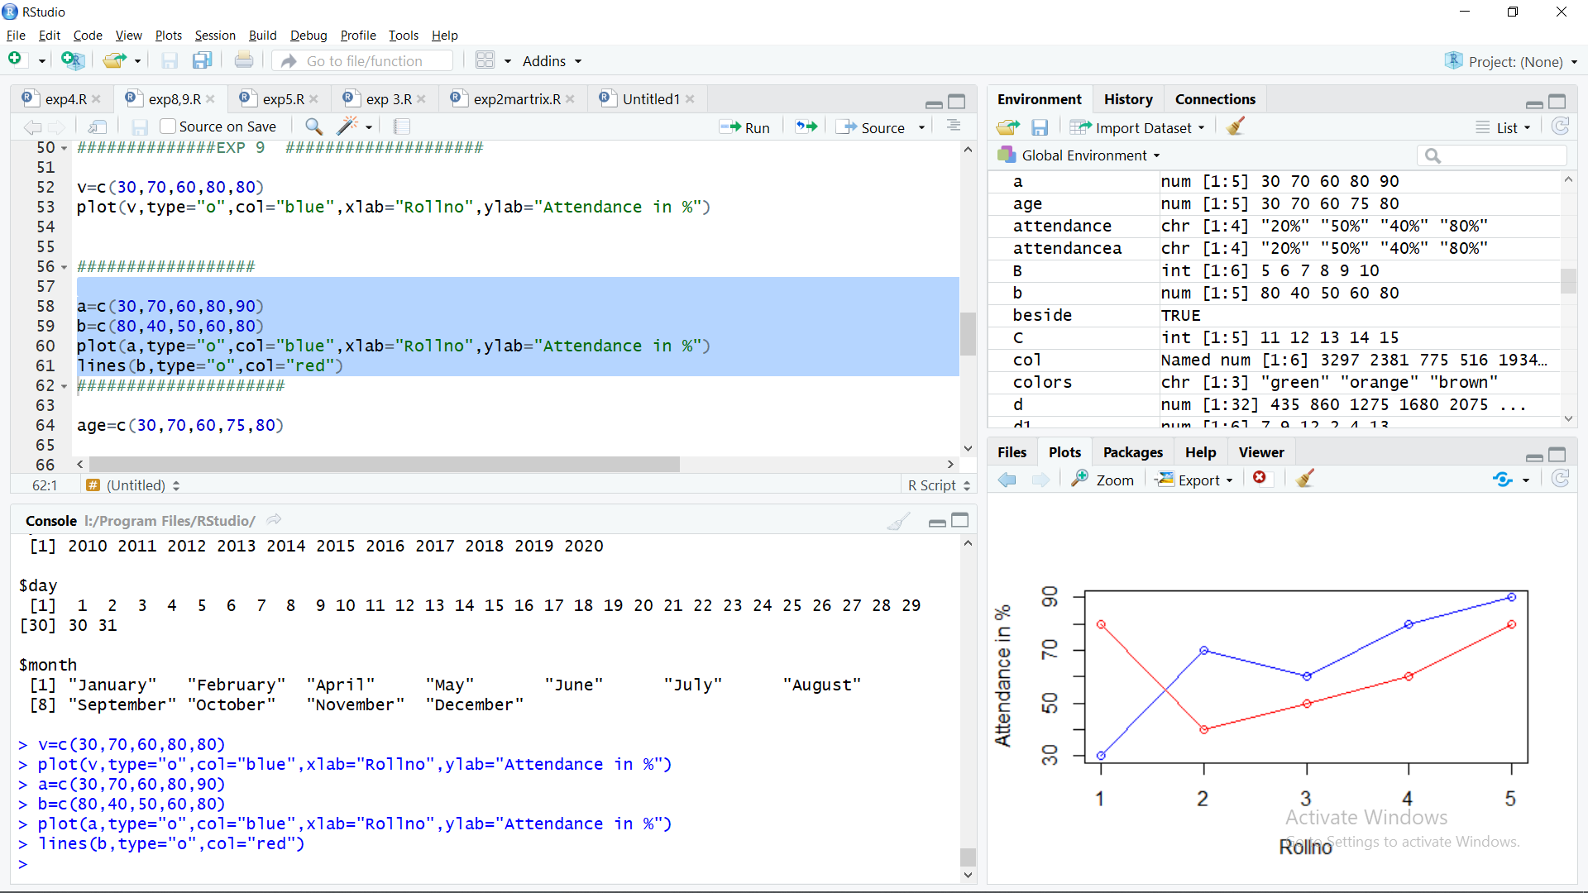

age=c(30,70,60,75,80)

barplot(age,col="blue",xlab="Months",ylab='Temperature',main="Monthly Temperature",

border="blue",

)

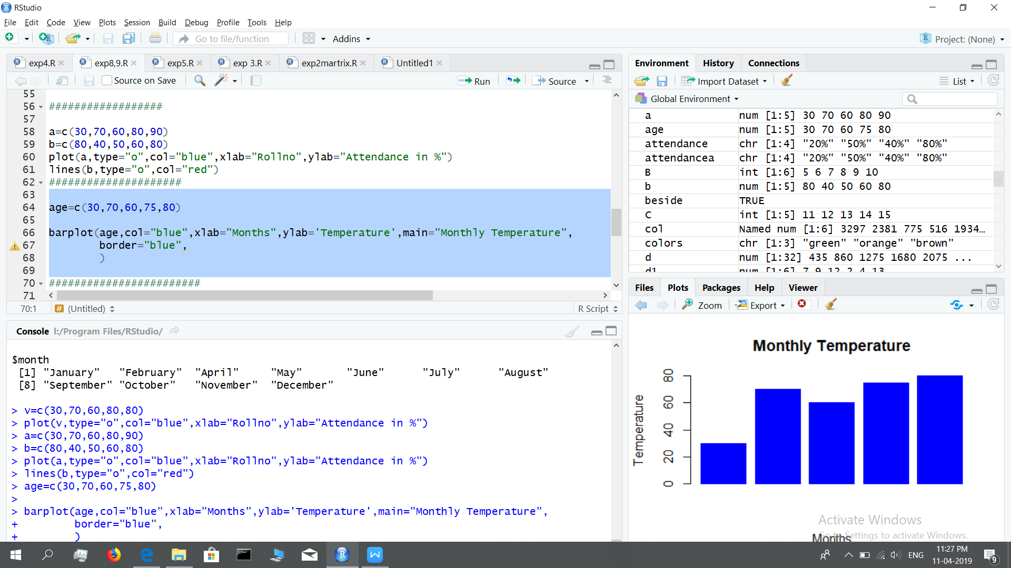

par(mfrow=c(1,2))

colors = c("green","orange","brown")

months <- c("A1","A2","A3","A4","A5")

regions <- c("East","West","North")

Values =matrix(c(30,48,10,70,71,72,60,61,62,67,68,69,56,90,98), nrow = 3, ncol = 5)

barplot(Values,names.arg = months,beside=TRUE, xlab = "Rollno", ylab = "Marks", col = colors,main ="Student result (3Sub)")

legend("topleft",cex=0.4,legend=c("DAA","DSR","OS"),fill= c("green","orange","brown"),bg="lightblue")

colors = c("green","orange","brown")

months <- c("A1","A2","A3","A4","A5")

regions <- c("East","West","North")

Values =matrix(c(30,48,10,70,71,72,60,61,62,67,68,69,56,90,98), nrow = 3, ncol = 5)

barplot(Values,names.arg = months, xlab = "Rollno", ylab = "Marks", col = colors,main ="Student result (3Sub)")

legend("topleft",cex=0.4,legend=c("DAA","DSR","OS"),fill= c("green","orange","brown"),bg="lightblue")

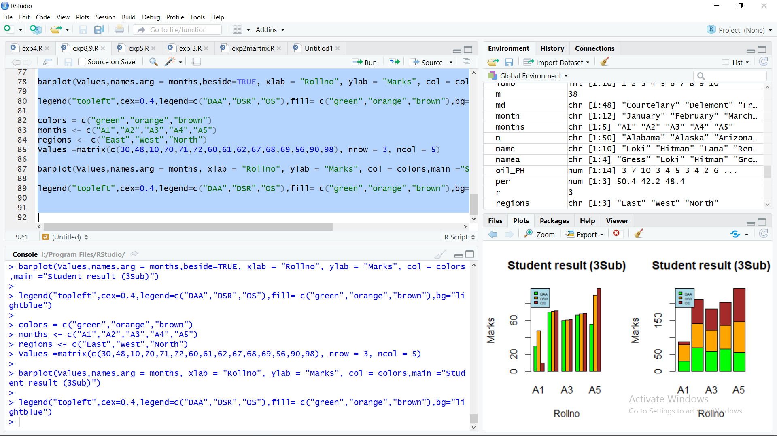

**EXP 6**

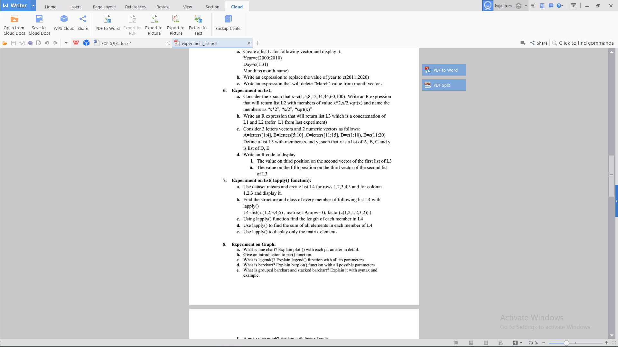

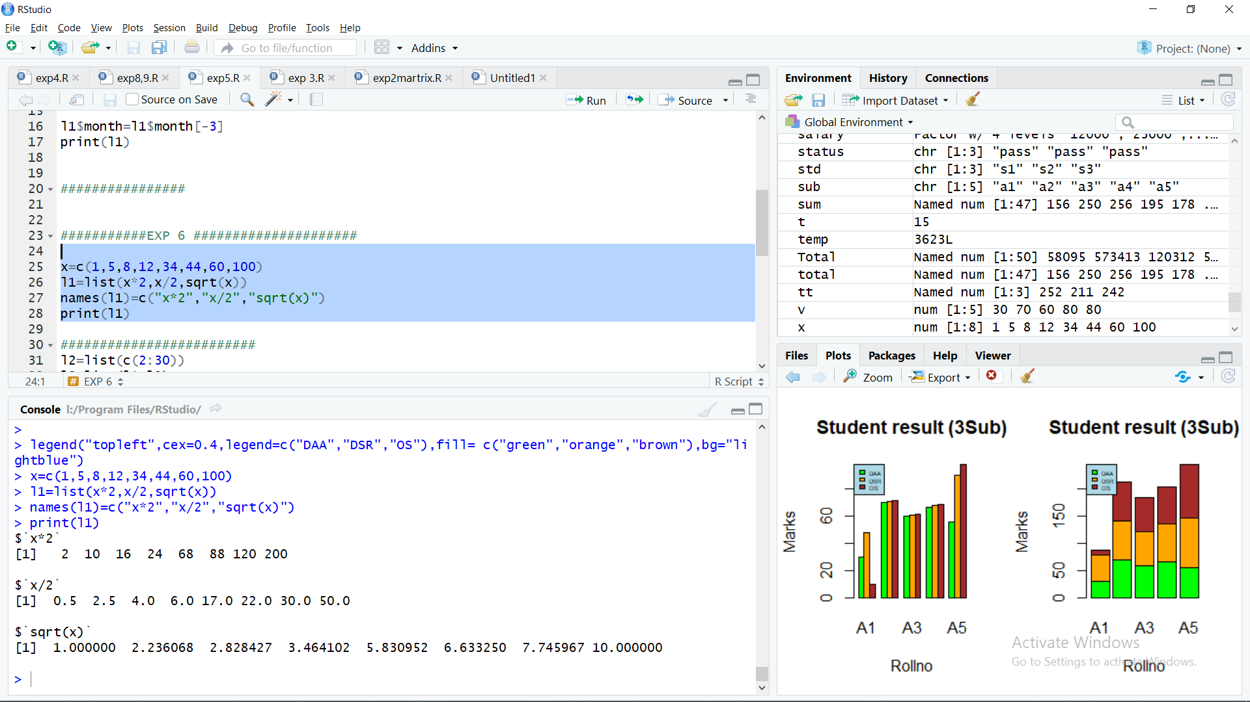

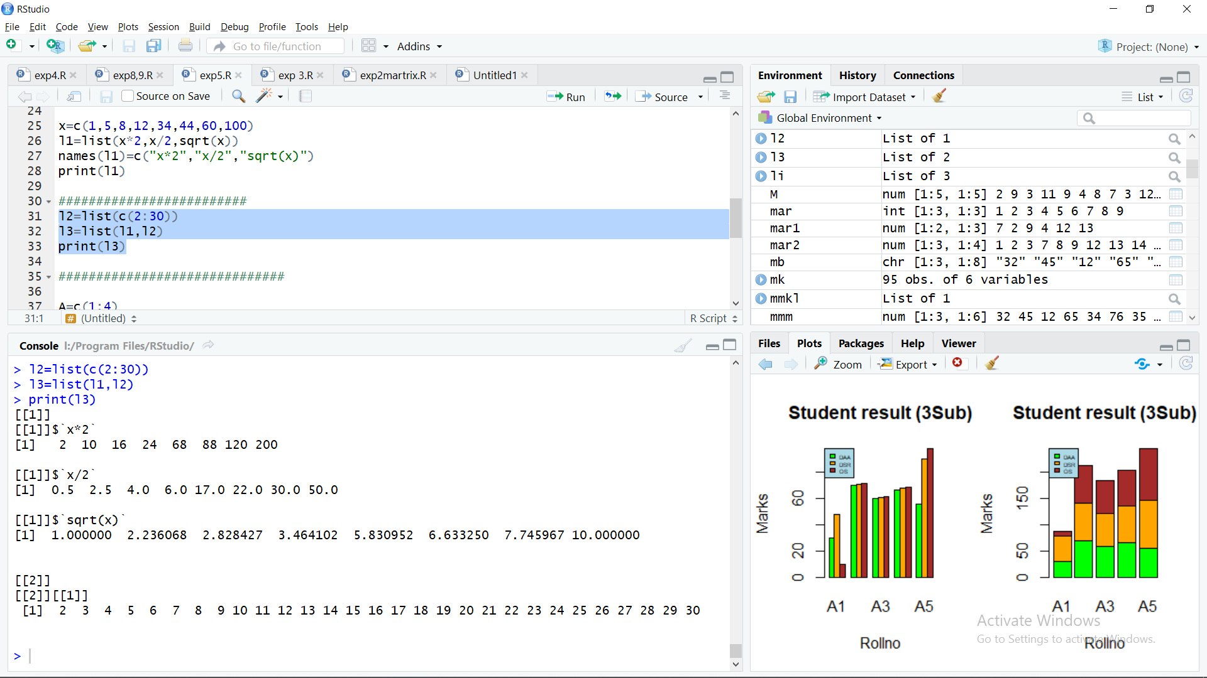

A=c(1:4)

B=c(5:10)

C=c(11:15)

D=numeric_version(c(1:10))

E=numeric_version(c(11:20))

x=list(A,B,C)

y=list(D,E)

l3=list(x,y)

print(l3)

